

FRONT-END WEB DEVELOPMENT

ASSIGNMENT

NAME: RAHUL NAYAK

REG. NO. 11907485

COLLEGE: LOVELY PROFFESIONAL UNIVERSITY

**TECHNOLOGIES AND FRAMEWORKS USED**

In order to create an e-commerce website, we used the following platforms:

VISUAL STUDIO CODE

Visual studio code is a source code which we use as an editor. We used it with java script. By using this visual studio code, we had made frame works in website designing. we had edit and build by using It. We had done the cooler coding by using same VS code.

Important features of visual studio code:

* These useful shortcuts come built-in to vs code, and they make writing HTML
* ESLint powerful linting tool .it helps us to stop errors in our code
* It is a lighting fast source code editor
* The integrated command line interface
* It can execute and debug JavaScript within visual code studio

**LANGUAGE USED:**

We have used HTML and CSS to develop our shop at home (our e-commerce website)

• For the simple one such as search bar font colours and back round colours we had used HTML

• For designing app logos and some optional clicking we had used CSS

**BACKGROUND**

As we all know Ecommerce website is a common method of Information and Product exchange in the modern era. Adding to the traditional business insight to the modern cult tech, E-commerce websites are a world in their own. Moreover, it has proved instrumental in increasing customer’s trust over a longer period of time. It is accessible and easy to use and navigate as well as a global platform for product and services. Building up a website is also a key for equality of market share and stocks when it comes to the neutrality of the e-commerce market.

Let’s have a look at the benefits that one can extract just by preferring a E-commerce website over traditional Retail Market:

• Keeps your online presence for 24x7.

• It cut costs that would better be invested elsewhere.

• Market Expansion can be a major factor for many.

• Advertising is the lifeline on which a business thrives.

• Growth Opportunity is maximum.

• Understanding Customer’s insights are quite useful in here.

• A lot more factors like credibility, easy transitions, competitors can play a major role in rocketing a business.

**MOTIVATION**

In the modern culture where E-commerce websites are already on the top there are many competitors in the market like Amazon, Flipkart and Myntra are a standard in themselves. This what developers call as Industry standard. We also aim to go as high as these aim at. Adding up we also have a lot of additional points for us to create this Website.

• To understand Customer Insight

• To make industrial level Website

• To take advantage from our knowledge

• To help us learn new insights

**OUTCOME OF THE PROJECT**

We were able to extract the maximum out of this project in order to give our best as well as to expand our domains of practical as well theoretical knowledge. Practically speaking, we achieved about 95% result of our expectation and we were quite happy how the results turned out to be.

Here are some briefs:

• A responsive Webpage

• An expanded dictionary of functionality

• Development at Personal Level

• A Small Pool of Products to navigate

**CONCRETE GOAL AND OBJECTIVE**

We look forward to expand this website further adding more technicalities and features. At the beginning to only had an aim to make a full functional ecommerce website that will be compatible to the modern internet world. And to our surprise we have successfully achieved our aim. Though we aimed at only realistic goals for our project all the problems that we have face in this journey is discussed in further details in the next articles.

Some of our Objectives and goals are as follows:

• Specific to Products

• Measurable Information Exchange

• Relevant to the most of the audience

• Expanding our genre of knowledge

• Improve Accessibility

• Build up Awareness among the Common

• Applying Marketing Strategies whenever possible and necessary

• Timely Achieving of all the above goals

**DESCRIPTION OF PROJECT**

MODULES

1. Product section/ Categories

In our ecommerce site we have so many different type of products with different categories our customers can buy in easy way due to defining of each and every product.

1. Sign up & Login:

These are the options customers must should do because by details our workers can sell our product in very easy way.

1. Header and Banner

The header and Banner are kept minimalistic as per the requirement of the assignments.

1. Footer:

Footer it is located in bottom of index page in this bar you can know about us better than anywhere in this website.

**SCREENSHOTS OF THE WEBPAGE**

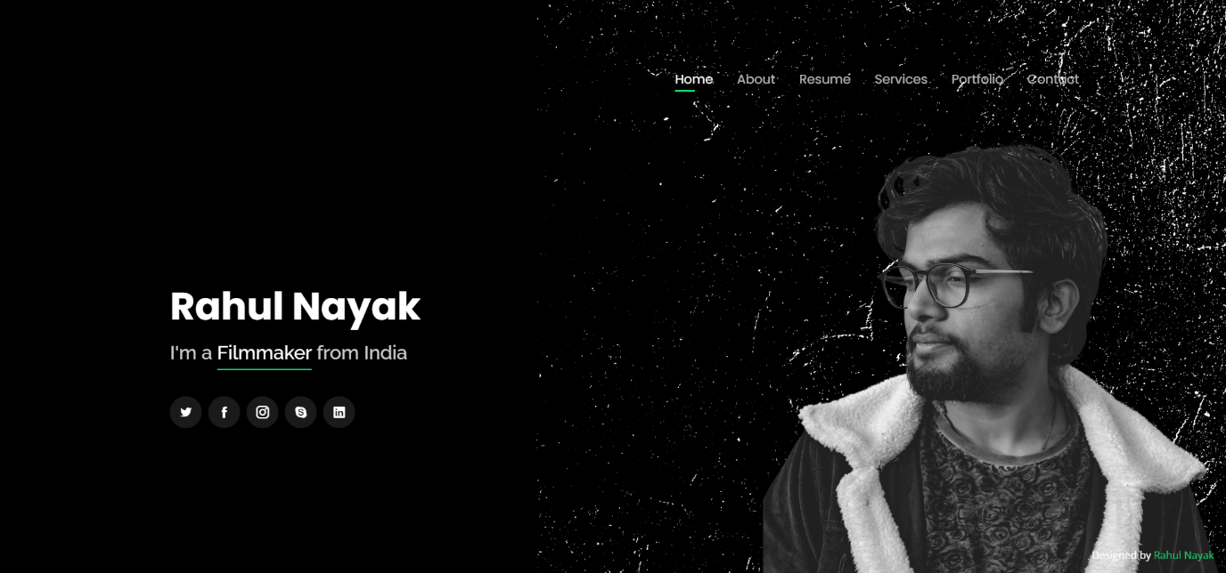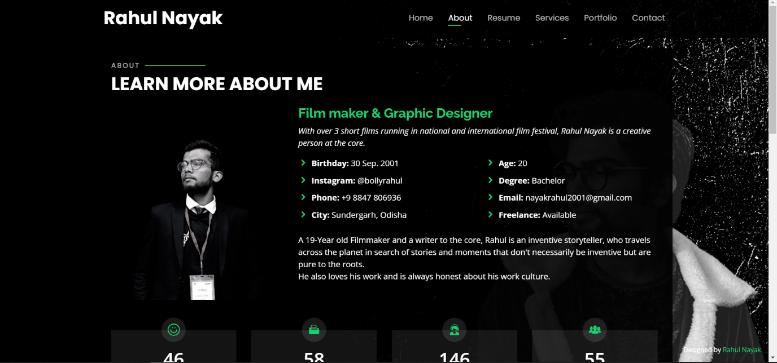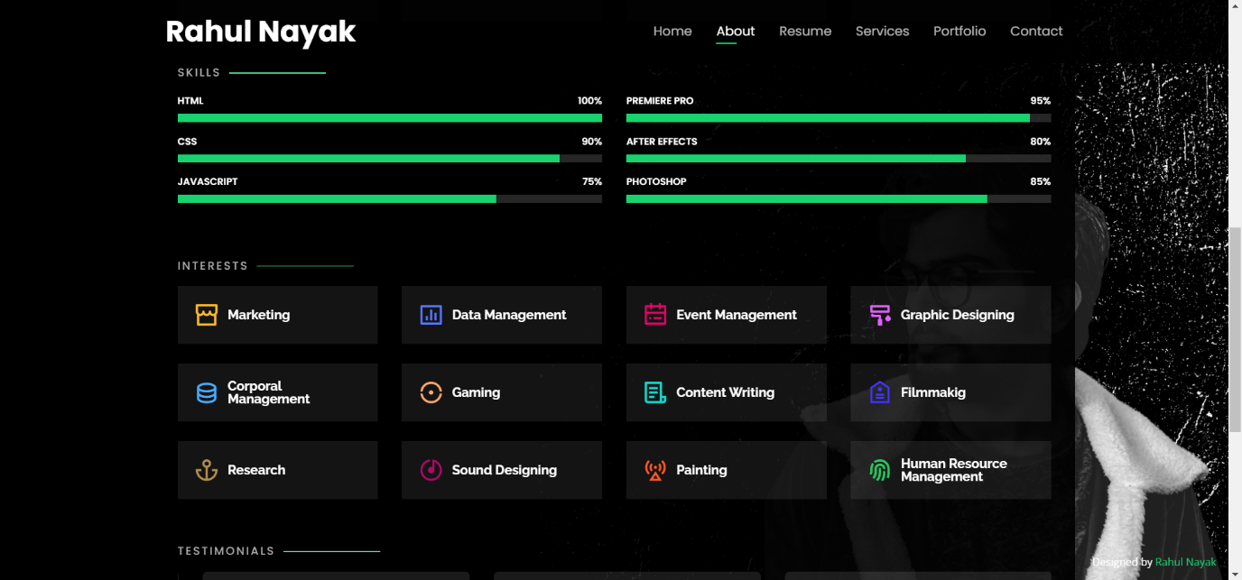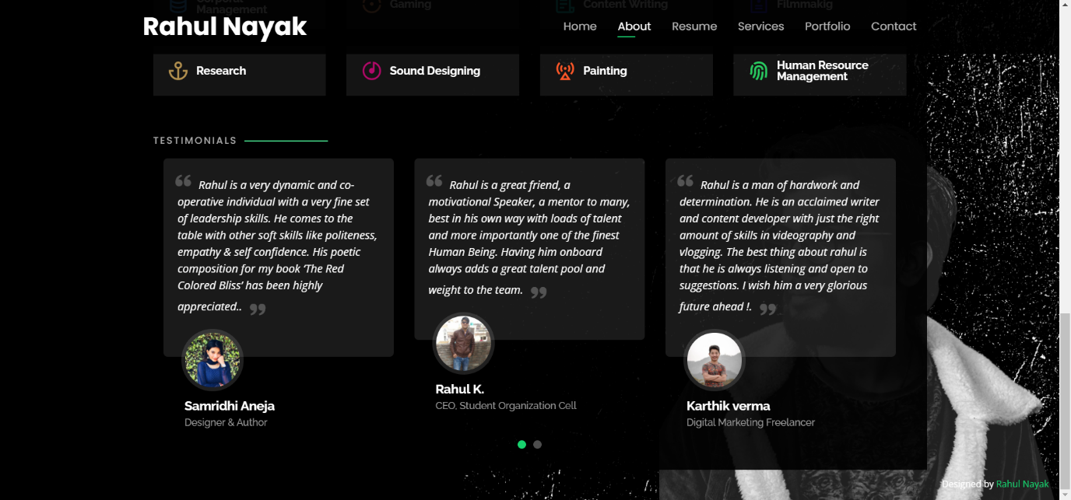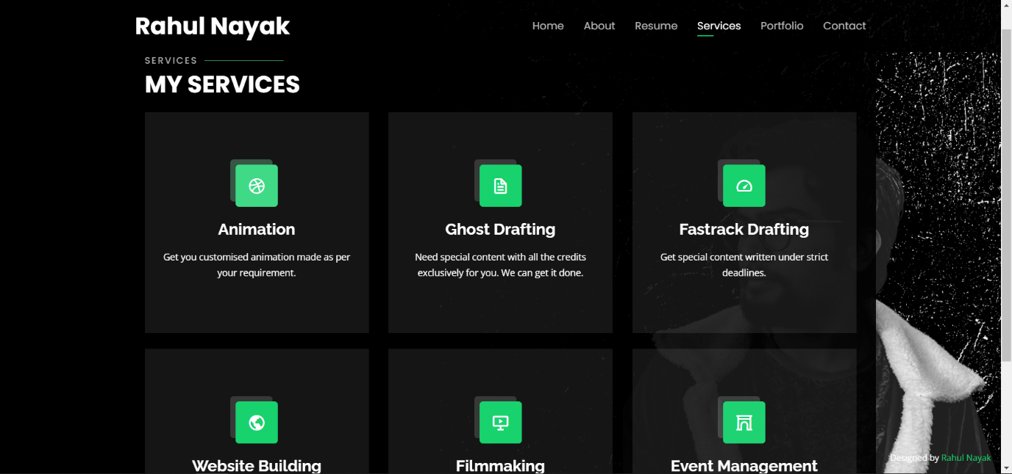

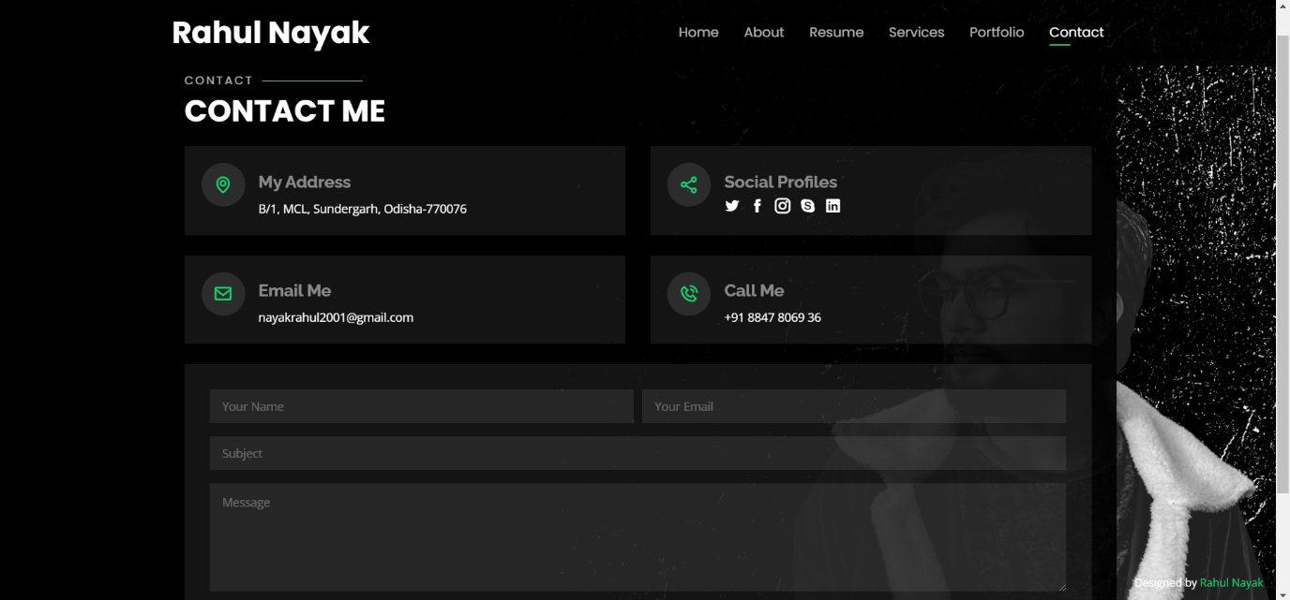GITHUB LINK: https://github.com/bollyrahul/portfoliowebsite